**Collect the dataset**

Download the dataset

This dataset contains **12,335 augmented images** of **fresh and rotten fruits and vegetables** in **JPEG format**, categorized and labelled by their condition (fresh or rotten). It includes commonly consumed items such as **apples, bananas, oranges, guavas, pomegranates, tomatoes, potatoes, jujubes, and mangoes**, grouped into folders based on fruit/vegetable type and freshness condition.

Each image is accompanied by corresponding labels (folder structure or CSV metadata) for supervised learning. The dataset is suitable for classification tasks and has been augmented with transformations like rotation, zooming, flipping, and brightness enhancement to simulate various real-world conditions.

Link:  <https://www.kaggle.com/datasets/paultimothymooney/blood-cells/data>

As the dataset is downloaded. Let us read and understand the data properly with the help of some visualization techniques and some analyzing techniques.

Note: There are several techniques for understanding the data. But here we have used some of it. In an additional way, you can use multiple techniques.

Activity 1.1: Importing the libraries:

Import the necessary libraries as shown in the image.

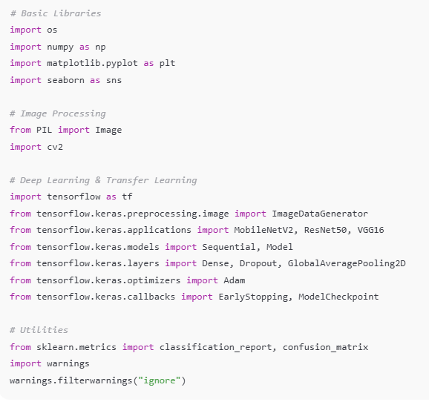

Activity 1.2: Read the Dataset:

* Our dataset format might be in .csv, excel files, .txt, .json, or zip files, etc. We can read the dataset with the help of pandas.

At first, unzip the data and convert it into a pandas data frame.

